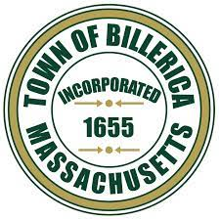

Town of Billerica
Long Range Master Plan Oversight Committee

AGENDA

Tuesday January 6, 2026
7:00 PM
Hybrid Meeting

In-person:
Town Hall, 365 Boston Rd. Collins Room (2nd Floor)

Remote Participation:
https://us02web.zoom.us/j/85223061867

- Call to Order
- Pledge of Allegiance
- Roll Call
- Election for Secretary
- Review of Table 5-1: Implementation Matrix
- Recommendation memo to Planning Board Discuss and possible vote
- Action Items for next meeting
- Next Meeting date(s)
- Adjournment

